Morrigan (pronounced MOR-rih-gan, with emphasis on first syllable), otherwise known as “Momo”  
Species/Creature: Witch

Appearance: Stereotypical depiction of a witch with green skin and extremely unappealing facial features; said depiction is heavily based on the Wicked Witch of the West from the Wizard of Oz. At least one wart, pointy nose, possibly yellow teeth and claws? Elderly/grandmotherly-type woman. Appearance meant to juxtapose her personality.  
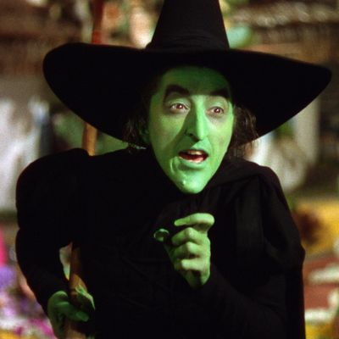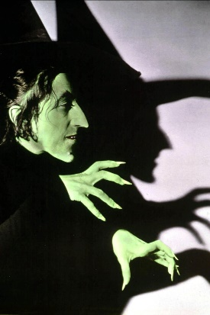

Personality: Incredibly sweet grandmother figure. Extremely compassionate, patient, and understanding; there’s not a single person in town who doesn’t like her.

Role: Was protagonist’s next-door neighbor growing up, always gave them candy and was happy to play with them. Babysat when needed. Protagonist kept in touch with them through letters. Tutorial character—used to introduce game’s basic mechanics as well as light exposition. Gushes how she’s so happy to see protagonist in person again, even if she didn’t expect them to return from the city (reasons for protagonist’s return will be revealed later). Comments about how the town’s changed a bit since protagonist left (NPCs that protagonist will not have met because they moved in after protagonist left), but still has the same spirit (there are several NPCs that the protagonist knows from childhood/before they left). If running out of time to implement other NPCs, she will likely get reused for some levels.